**Diagrams and Sketches**

**The description of each component**

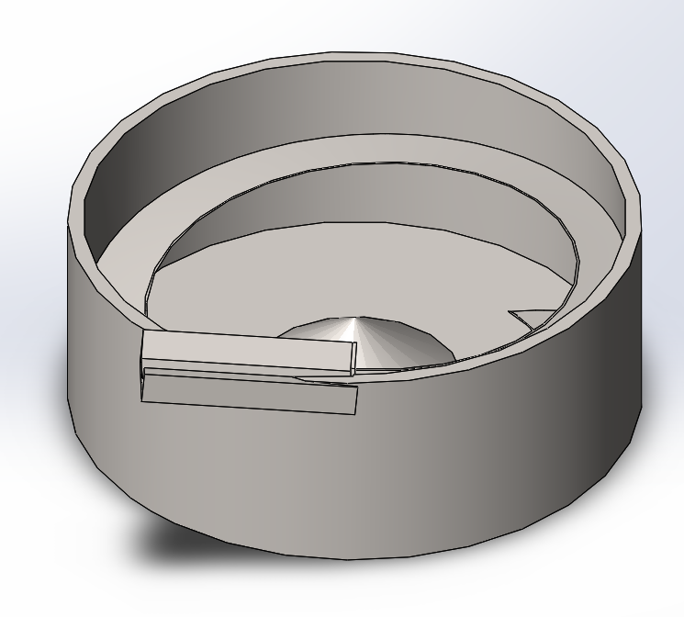

1. 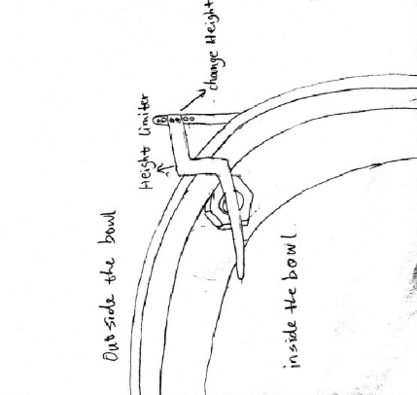Bowl feeder - serves as a hopper and transducer placed at the rear-end of the system

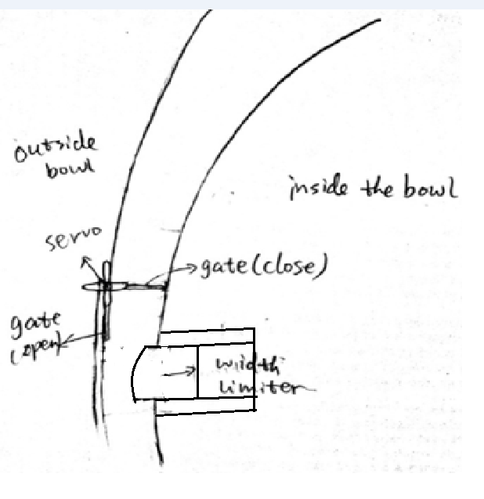

1. Inside the bowl - a control gate that is attached to an RC servo motor, and the spline that ascends to the top of the bowl and narrows along its path.

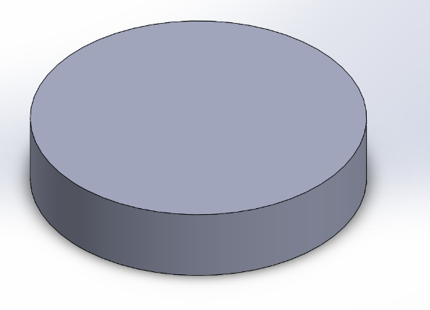

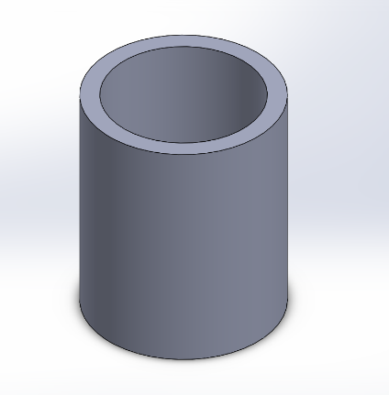3. Counter weight - The vibratory action of the bowl to begin and agitate the parts in the bottom of the bowl to start to move along the dispense path.

4. Parts counting chute - Attached to the tube are 6 pairs of diametrically opposing photo electronic sensors, evenly spaced to count parts to be dispensed and measure the velocity of those parts.

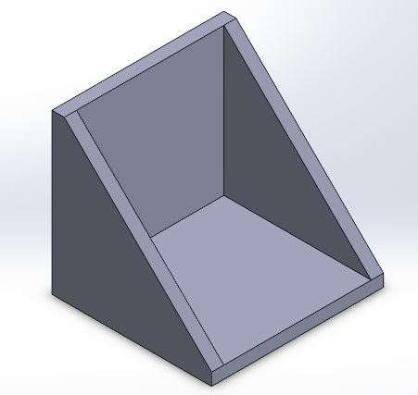

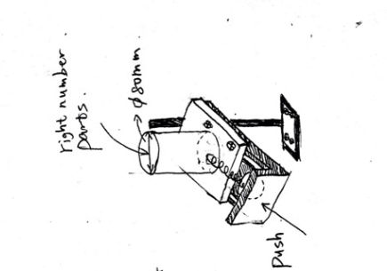

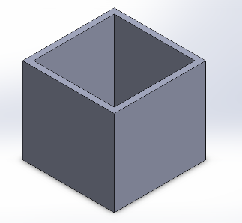

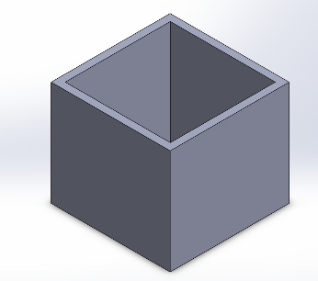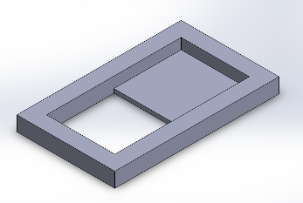

5. Count staging part, rejection bin, and presentation bin.

**Frame Assembly**

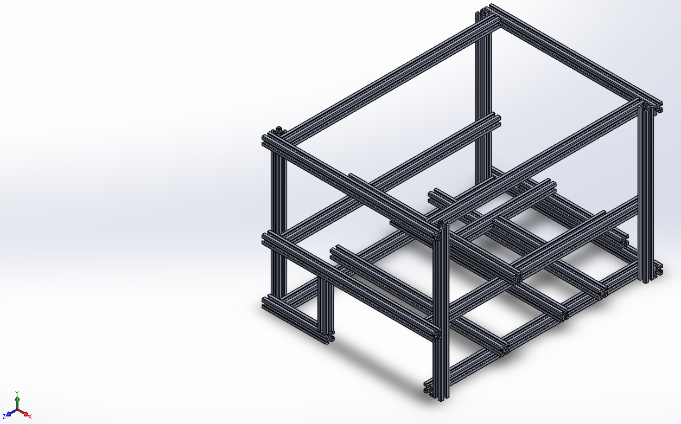

6. Frame uses 20mm X 20mm aluminum 80/20 beams. That can be cut to length and fixed to support the rest of the assembly inside.

**Final Assembly**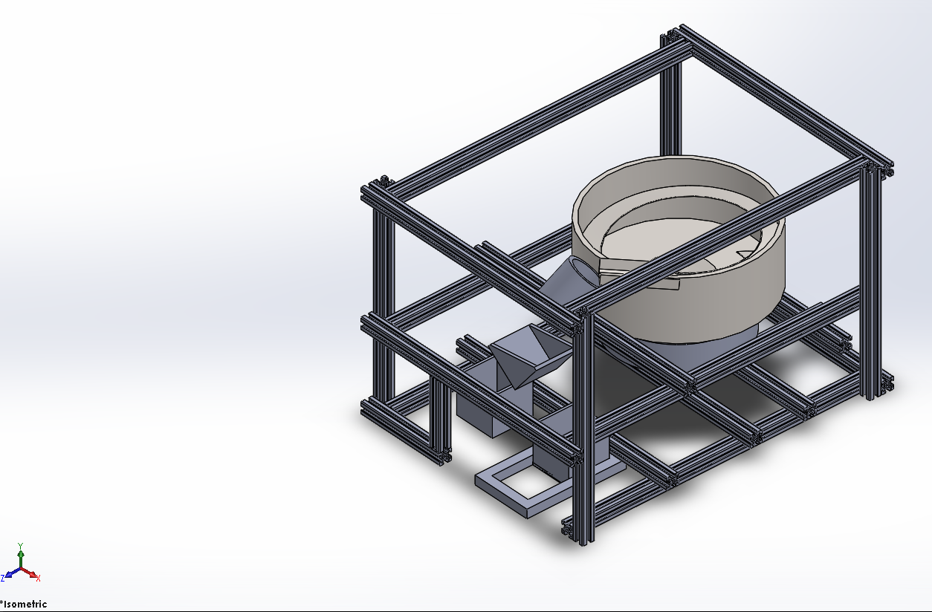

7. The final picture of all the components in their relative positions.

**Potential Markets and Applications**

The system could efficiently and accurately count parts needed by an assembly worker and dispenses those parts into a worker’s awaiting hand. This kind of function can be applied on manufacturing as an advanced manufacturing facilities that can save a lot of time and labors. Before packaging, catching the exactly number of parts is important. Instead counting the parts by human being, a proper machine can do the work effectively and concisely. Additionally, the machine can count different types and different numbers of small parts by easily changing or adjusting the components. Although the system is now just suitable for no more than 50 parts, it can be developed to fit more parts to work better in the real industry. Further, this vibration system also can not only used to count one kind of parts, after some changes, it also can be used to classify different kind of parts, which will be very useful in the industry applications.

